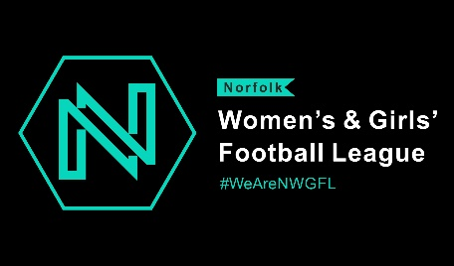
TEAM REGISTRATION 2022/23
Please complete each section clearly
TEAM NAME________________________________________________________________
AGE GROUP - U7☐ U8☐ U9☐ U10☐ U11☐ U12☐ U13☐ U14☐ U15☐ U16 ☐ U18☐ Ladies 7☐ Ladies 11☐
SEASON 2022/2023
MANAGER CONTACT NAME____________________________________________________
MOBILE NUMBER (A mobile number must be provided for Fulltime text result system) ___________________________________________________________________________
EMAIL ADDRESS (Please print clearly) ____________________________________________
I give consent for my name, email address and contact mobile number to be visible on NWGFL website - Yes ☐ No ☐
CLUB SECRETARY_____________________________________________________________
ADDRESS___________________________________________________________________
_______________________________________________POST CODE__________________
TELEPHONE NUMBER_________________________________________________________
EMAIL______________________________________________________________________
CLUB WELFARE OFFICER_______________________________________________________
ADDRESS___________________________________________________________________
___________________________________________________POST CODE ______________
TELEPHONE NUMBER_________________________________________________________
EMAIL______________________________________________________________________
PITCH VENUE________________________________________________________________
DIRECTION__________________________________________________________________
___________________________________________________________________________
__________________________________________________POST CODE________________
TEAM COLOURS______________________________________________________________
Manager contact details will be available on the Members only area of the league website unless indicated consent above for them to be visible.
The Chairman and the Secretary of each Club shall complete and sign the following agreement which shall be deposited with the 'League' together with the Application for Membership for the coming season, or upon indicating that the Club intends to compete.
"We, ,_____ _______________ ___ of______________ _________________________(Chairman) and
_____________________________of______________ _________________________(Secretary)
of the _________________________________Club
Football Club have been provided with a copy of the Rules and Regulations of the Norfolk Women’s & Girls Football League and do hereby agree for and on behalf of the said Club, if elected or accepted into Membership, to conform to those Rules and Regulations and to accept, abide by and implement the decisions of the Management Committee of the 'League', subject to the right of appeal in accordance with Rule 7."
Any alteration of the Chairman and /or Secretary on the above Agreement must be notified to the Norfolk County Football Association(s) to which the Club is affiliated and to the General Secretary of the 'League'.
(Note: The spaces above are intended for the inclusion of the signatures and addresses of officers and members).
Please indicate team entry fee payment details as below:
Paid by BACS: Date of payment: …………………………………………… Amount £………………………………………………
Paid by cheque: Date of payment:……………….……………………………. Amount £……………………………………………..

